<https://www.learningchocolate.com/content/christmas?st_lang=en>

<https://www.eslprintables.com/vocabulary_worksheets/holidays_and_traditions/christmas_/christmas_game/Christmas_Vocabulary_Memory_Ga_850763/>

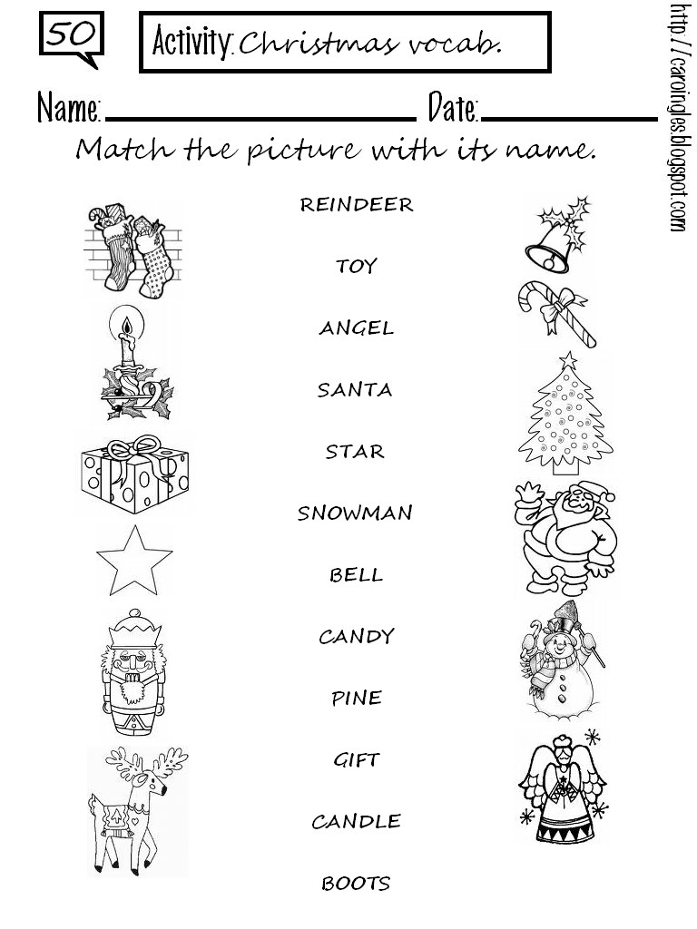

<https://agendaweb.org/exercises/vocabulary/christmas/words-2.htm>

<https://agendaweb.org/exercises/vocabulary/christmas/match-2.htm>

<https://agendaweb.org/exercises/vocabulary/christmas/words-3>