Old and new sights in London

London, the capital of the U.K. has many tourist attractions famous all over the world. Some of them are very old like The Houses of Parliament and Big Ben, but some are quite new like Madame
Tussead's wax museum or the London Eye. The following extracts from tourist sites about London, give you information about some of them.
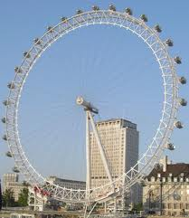

The London Eye

Built as part of the year 2000 millennium celebrations, the London Eye seems to have captured the imagination of visitors to London. It is now one the most popular attractions of all.

The London Eye is situated right at the tourist heart of London, (opposite Big Ben by the River Thames) with commanding views, (25 miles on a good day).
You ride in a luxurious capsule in comfort.

The attraction was originally sponsored by British Airways, so rides are called flights. The eye is besides the River Thames on the opposite bank to Big Ben.

Each capsule is also fully air-conditioned to keep its visitors completely comfortable no matter what the temperature outside. See the Gothic houses of Parliament, Westminster Abbey, The Tate Museum, or the Tower Bridge.

The London Eye is a victim of its own success. Turn up on the day and you will have to queue and wait.
The area is crowded and heavily littered with fast food rubbish.

London Eye Ticket Prices

March 2011 - March 2012 Admission
Adult: UKP 18.00
Child, 4-14: UKP 14.65
Child, under 3: Free
Senior, 60 +: UKP 14.65
Registered Disabled: UKP 14.65

taken and adapted from “ The London Toolkit”, http://www.londontoolkit.com/whattodo/kids.htm
and “London eye Tickets an Info” http://www.londonnet.co.uk/ln/guide/about/londoneye.html

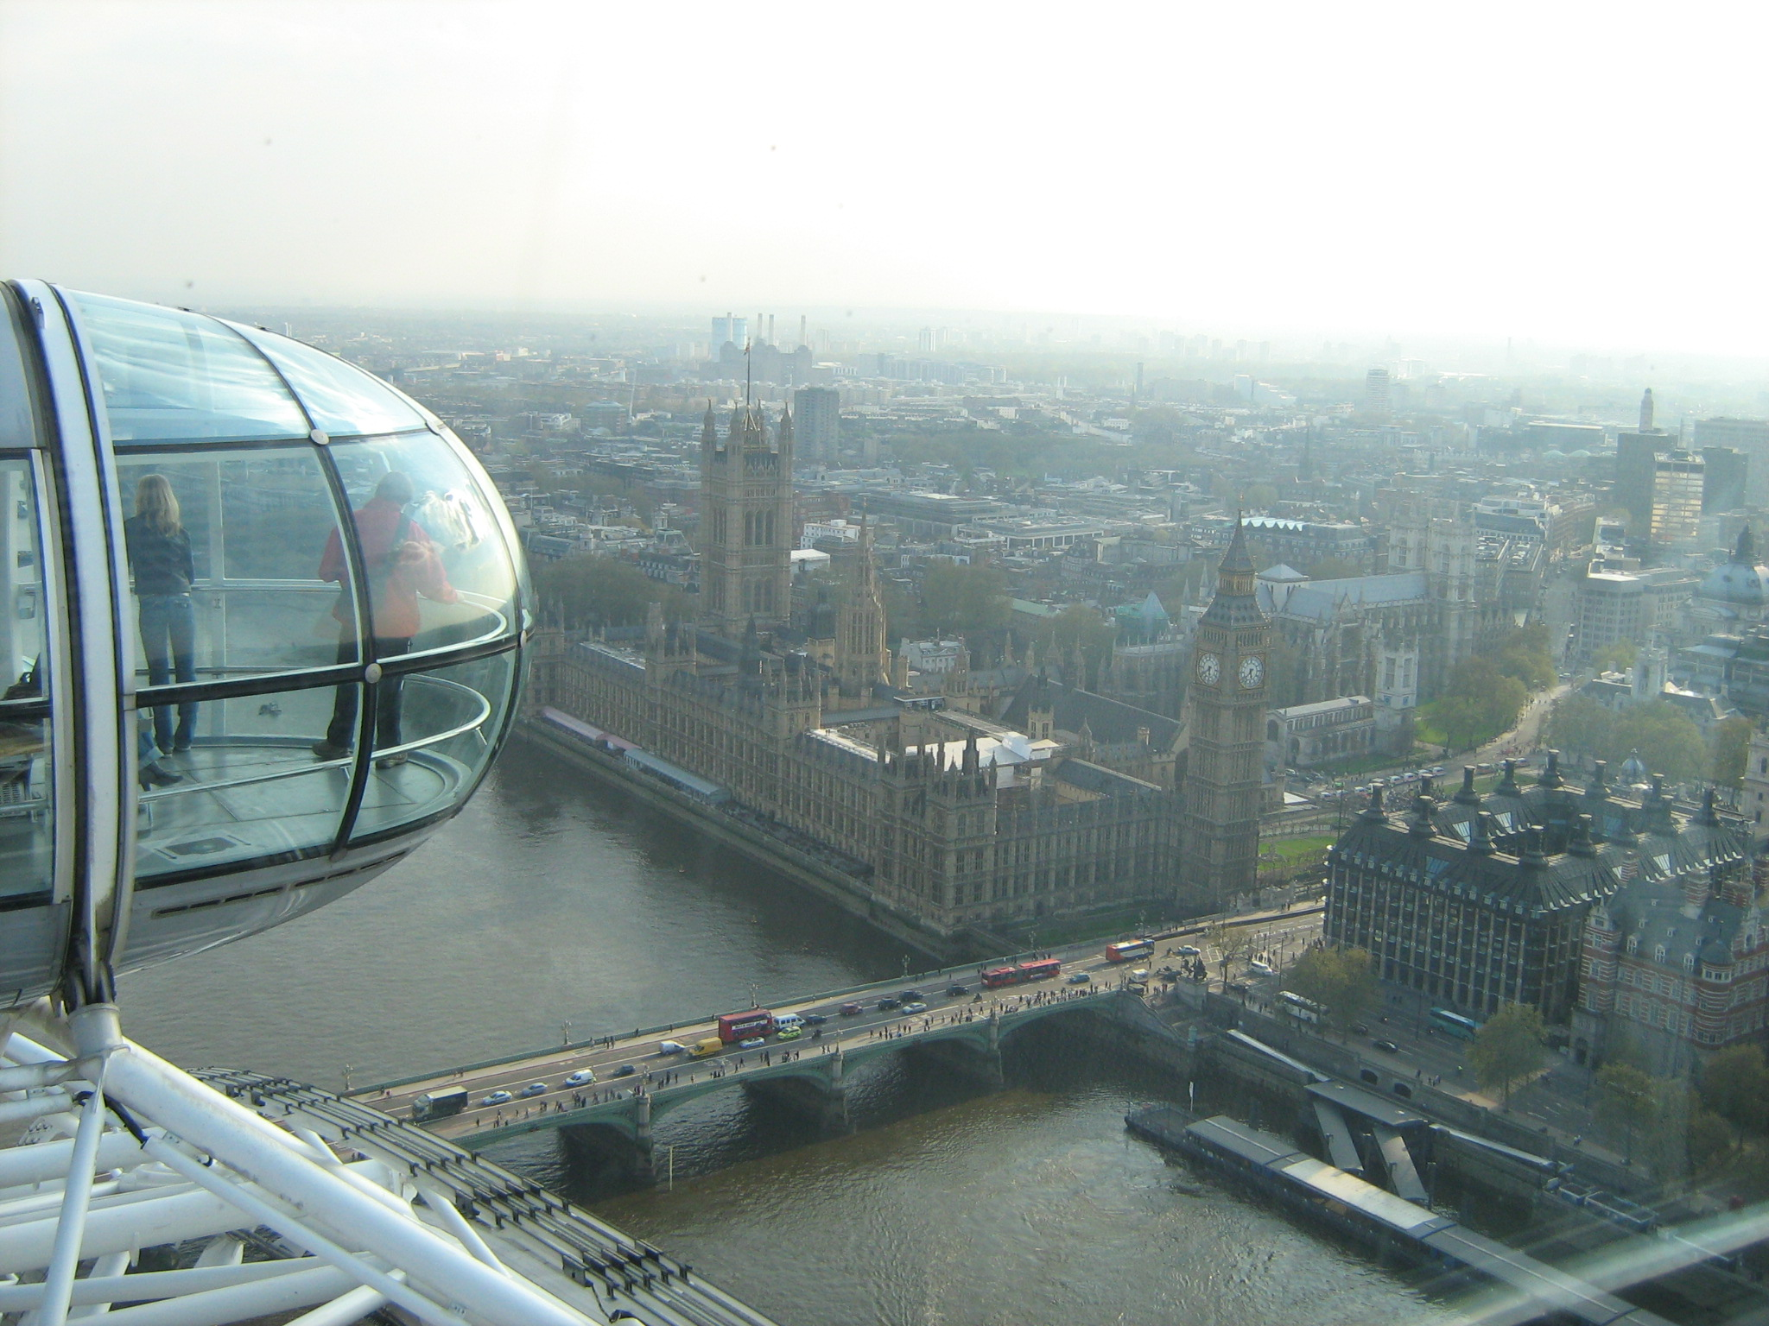

Tower of London
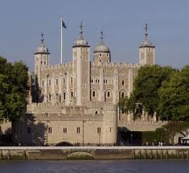
History

Founded by William the Conqueror in 1066-7 and changed by following kings and queens, today the Tower of London is one of the world's most famous and spectacular fortresses. In its time it has been a royal palace, a fortress, a prison, an armoury, a treasury and an astronomical observatory.

The Tower of London sits by the River Thames very near to Tower Bridge. It's probably one of the few times most visitors will be inside the original city walls of London, now the city's financial district.

Today
Today it's one of the most popular attractions in London for people of all ages.

Once in the Tower of London you can take advantage of a one hour guided tour by a costumed Beefeater. These run normally every half-hour throughout the day.
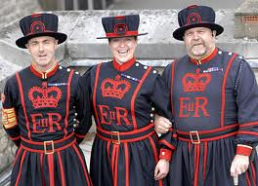

The Tower's greatest attraction the Crown Jewels are housed in the White Tower. You will normally have to wait in long lines to get to see the jewels. You will see some of the world's most precious jewels set into swords, robes, and of course crowns. The Imperial State Crown is still used today by the Queen of England for ceremonial occasions.

Tickets

For visits  1 Mar '11 - 28 Feb '12 incl. | Individual rate* | Individual online rate+ | Group rate  (min. 15 visitors)
Adult | £19.80 | £17.00 | £16.20
Child (under 16)  Under 5s are free of charge. Children must be accompanied by an adult. | £10.45 | £9.00 | £8.55
Concessions  Full-time student, over 60 with ID | £17.05 | £14.50 | £13.95
Family  Up to 2 adults and 6 children | £55.00 | £47.00
Annual membership  (unlimited entry to five palaces) | From £43.00

taken and adapted from “ The London Toolkit”, http://www.londontoolkit.com/whattodo/kids.htm
and “ Historical Royal Palaces” http://www.hrp.org.uk/TowerOfLondon/admissionsprices/toweroflondonadmission

WORKSHEET 1 (classwork in groups)
Activity 1:
Work in groups and try to answer the questions:
Use LE for London Eye or TL for Tower of London.

1 . Which is new? _____________________
2 . Which is old? _____________________
3 . Where are the Crown Jewels? _____________________
4 . Which one offers “flights” ? _____________________
5 . Where are children under 5 free? _____________________
6 . Which has rubbish all around? _____________________
7 . Which of the two attractions offers a guided tour? _____________________
8 . Which has a special year round ticket ? _____________________
9 . Which offers the best panoramic view? _____________________
10 . Which used to be a prison? _____________________

Activity 2
Choose the best answer:

1 . From the London Eye you can see a ) British Airways planes
b ) 25 miles away
2 . London Eye is built next to a ) river Thames
b ) the Big Ben
3 . Guided tours are offered in a ) the London Eye
b ) the Tower of London
4 . The Imperial State Crown belongs to a ) Prince Charles
b ) Queen Elizabeth
5 . It used to be an astronomical observatory a ) the London Eye
b ) the TowerOf London

Activity 3

In groups describe one of the pictures you see on the pages given ( about 50 words) :
(Useful expressions:)
In this picture I can see....
It is round/ small/ big .. etc
In the background I can see..
It was built/ made in … by …
I like/ don't like it because..

Activity 4
Art and Role playing
Your group must choose one sight, and cut out little papers to make “tickets” in order to play “Ticket House” . You can also make “paper money” to use.
Two pupils of the class are the cashiers who sell tickets for the sights. The rest of the pupils form groups of visitors ( family, friends, grandparents and grandchildren etc ) and form two orderly queues, to buy tickets.

WORKSHEET 2 (homework)
Activity 1
Count up how much you will have to pay.

A. You are visiting The Tower of London . How much will you have to pay if :

1 . You are a family of two parents with 3 children over 6 and have booked on line ?________
2 . You are a family of one parent and one 4-year-old child? _______________
3 . You are visiting with your classmates (twenty 14-year-olds) ? _______________

B. You are visiting the London Eye. How much will you have to pay if :

1 . You are a family of two parents, one 6-year-old and one 2-year-old ? ______________
2 . You are 67 and going with your 9-year-old grandson? _______________
3 . You are group of four 20-year-olds? _______________

Activity 2

For homework find information on the internet about two other famous sights in London.
You can use ideas from the introduction, and the URLs given.
You may also want to try Buckingham Palace, Tower Bridge or Hampton Court.
Bring the information in class and make a collage with your group presenting the sights you have found.

